**Brought to you by [INSERT YOUR PROGRAM HERE]’s “Surgical Babushka Program”**



We’re sorry that you’re sick, but we’ll do everything we can to get you better faster!

* We know you’re a doctor… But even doctors get sick and need to be taken care of!
* In your package you’ll find medications, healthy foods, and hydration.
* Please read instructions and take medications as instructed.
* We will check in with you tomorrow and every day until you’re feeling better.
* If you feel worse or this little package isn’t enough, call your doctor or an ambulance. Let us know how we can assist you!
* Please take 30 seconds to fill out the survey that we will email you after you’re better so that we know if we should continue doing this in the future.

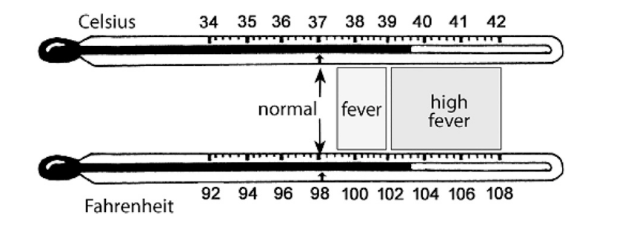

**This package contains** [update accordingly]:

* Ibuprofen 200 mg tab - EXPIRES [insert date]. Take up to 600 mg every 6 hours PRN pain/fever
* Tylenol 500 mg tab - EXPIRES [insert date]. Take 500-1,000mg every 6 hours PRN pain/fever, MAX 4,000 mg/day
* DayQuil - EXPIRES [insert date]. Take 2 tablets every 8 hours PRN fever/congestion.
* NightQuil- EXPIRES [insert date]. Take 2 tablets every 8 hours PRN fever/congestion before sleep.
* Cough drops, Ricola - EXPIRES [insert date]. PRN sore throat/cough
* Cold-EEZE - EXPIRES [insert date]. Dissolve 1 tablet in 8oz of water and drink daily while sick.
* Emergency Immune Support, take once daily PRN for additional vitamins (take either emergency or airborne, dissolve in water).
* Airborne Immune Support, take once daily PRN for additional vitamins (take either emergency or airborne, dissolve in water).
* Food (soup, Gatorade, tea)

*The greatest gift you can give to your patients is a healthy you!*

*Take care of yourself so you can take care of others.*

*[insert your Babushka contact information/email here]*